Welcome, Baimbridge College
- Management>
- International Education >
- Sister School Partnerships

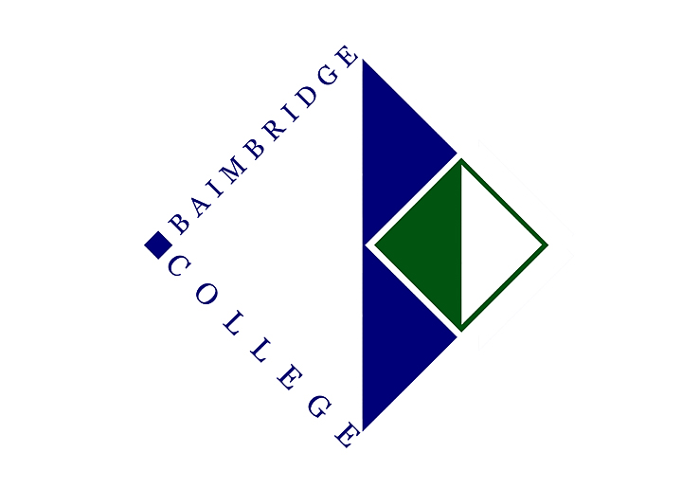
85 Stephen Street , Hamilton , Victoria 3300 , Victoria , Australia
w: Baimbridge College Website
|ph: +61 03 55722788

Key Contacts

Mr Robert Vecchiet
Principal
E: vecchiet.robert.r@edumail.vic.gov.au
P: +61 03 55722788
Mr Marco Antonelli
Languages (Italian) Learning Area Coordinator
E: antonelli.marco.m@edumail.vic.gov.au
P: +61 03 55722788

About my School

Primary language used in school:
English

Foreign languages taught in school:
Italian
School type:
Secondary (Years 7-12) , Government
Is mixed or single-sex:
Mixed
Number of students:
501-1000

Specialisation:
Music

Special needs support:
Yes, some of our students have special needs

Collaboration Options

Project Preference:
Sister School Partnership (school to school partnership)
Partnership Country:
Italy
Partnership Outcome:
The Italian language has been a key part of Baimbridge College curriculum for some years now. At the moment, Italian is taught at Year 7 and 8. Moreover, most of the state primary school of this region has incorporated Italian as part of their curriculum. Baimbridge College would greatly benefit from finding a sister school in Italy. A sister school partnership program would involve different activities, including E-pals, Skype calls, students/teachers exchanges, and curriculum exchanges.
Preferred Partnership Activities:
Class to class email; Student visits; Teacher exchange; Teacher visits; Video communication
Preferred contact method:
Email
Profile Active / Inactive
Active

Terms and Conditions

I have read and agreed to the Terms and Conditions
Schools Connect

