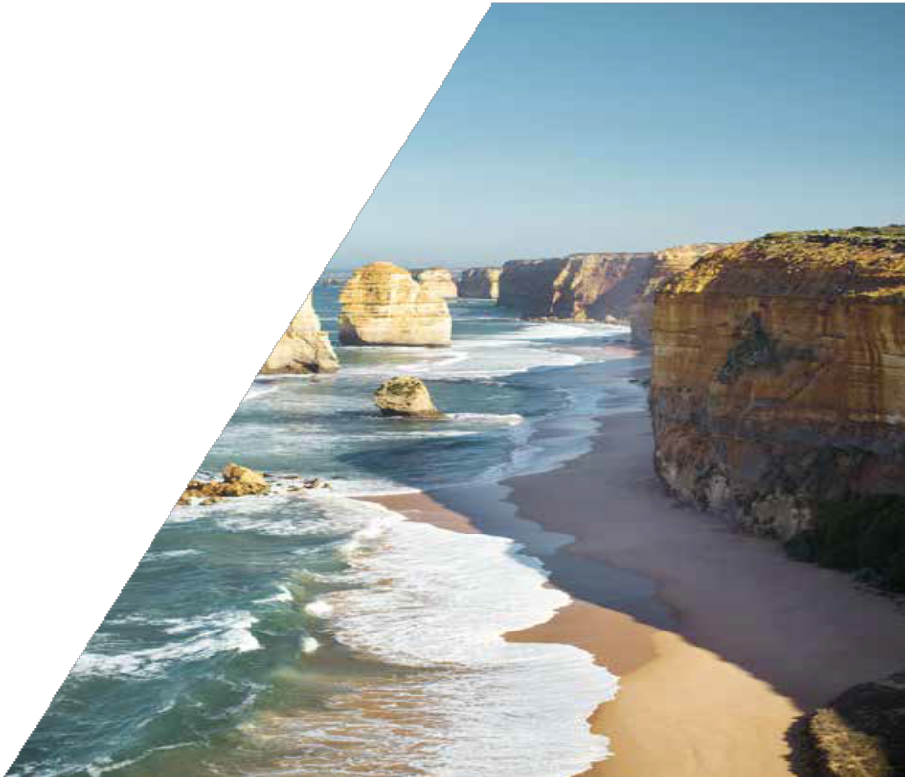

Study Tours
VICTORIAN GOVERNMENT SCHOOLS
Department of Education Melbourne, Victoria, Australia

Short-term study tours hosted by Victorian government schools offer students educational benefits such as:
- school activities such as a welcome and school orientation and integrated classes with local students
- small English as an Additional Language (EAL) classes with a qualified EAL teacher to gain confidence in English skills
- exciting excursions that are age-appropriate and tailored to the interests of the group.

Study tours can be from 1 day to 4 weeks in length. They may have a theme such science, technology, engineering and mathematics (STEM), sustainability, the arts, or Aboriginal and Torres Strait Islander culture.
Excursions can range from cultural attractions like zoos, museums and galleries, to places of breath-taking natural beauty like the Great Ocean Road and the Penguin Parage at Phillip Island Nature Park.

MY BEST EXPERIENCE OF THE STUDY PROGRAM WAS THAT I COULD TALK WITH MY HOST BUDDY A LOT, AND MADE GOOD FRIENDS WITH HER. I WAS VERY HAPPY TO SPEND A LOT OF TIME WITH HER AT HOME AND AT SCHOOL.
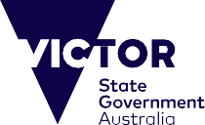
I ALSO GOT TO LIKE ENGLISH BETTER THAN BEFORE THANKS TO HER.

Benefits of participating
Victoria is one of the world’s leading study destinations, and study tour participants have the opportunity to get a taste of what it is like to live and study in Victoria. Students are immersed in another culture and participate in engaging activities and excursions designed to enhance their self-confidence, English language skills and intercultural understanding. Students may participate in a study tour as a one-off activity or could consider returning as a longer-term international student in the future.

Planning a study tour

Who can participate Students aged 10 and above.
Group sizes
Study tour groups range in size from 10 to 20 students, with two accompanying adults, hosted by one school.
Accompanying adults do not pay study tour fees.
Duration
1 day to 4 weeks during Victorian government school terms.
Sample study tour program Victorian study tours are tailored to provide student groups with positive
educational experiences. Study tour
activities and excursions can be tailored to the interests of the group. Please see the table on the next page for a sample study tour program.

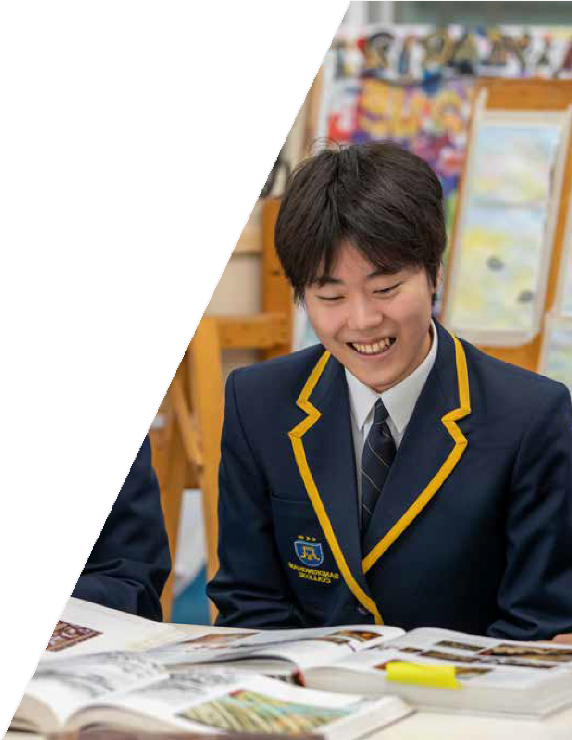
Sample study tour program at a Victorian government school

Date | AM | PM | Days
Sunday 1 October | Arrive in Melbourne
Monday 2 October | Welcome ceremony  Orientation at host school - with student buddies | Join local students in class | 1
Tuesday 3 October | EXCURSION 1: Phillip Island Nature Park |  | 2
Wednesday 4 October | English language activities | Join local students in class | 3
Thursday 5 October | EXCURSION 2: Melbourne Zoo |  | 4
Friday 6 October | Join local students in class | Farewell ceremony with Certificate of Participation | 5
Saturday 7 October | Depart Melbourne
Contact a study tour operator
Victoria’s Department of Education works in partnership with accredited Study Tour Operators to facilitate study tours.
Please contact a Study Tour Operator listed on https://www.study.vic.gov.au/en/ Pages/contact.aspx to arrange a study tour.

Published by the International Education Division, Department of Education, Melbourne
© State of Victoria (Department of Education) 2023 Authorised by the Department of Education,
2 Treasury Place, East Melbourne, Victoria, 3002. ISBN 978-0-7594-0700-8
Accessibility
If you would like to receive this publication in an accessible format, such as audio, please telephone 1800 809 834,
or email edline@vic.gov.au

