Welcome, Colegio Purísima Concepción y Santa María Micaela
- Management>
- International Education >
- Sister School Partnerships

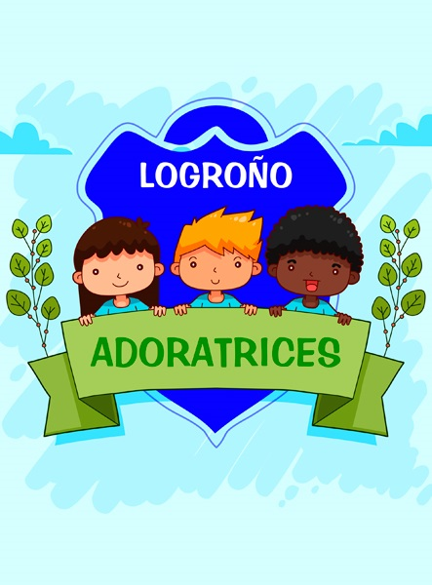
Calle Juan XXIII Nº 10 , Logroño , La Rioja 26003 , La Rioja , Spain
w: Colegio de Educación Infantil, Primaria, Secundaria, Ciclos Formativos y Formación Profesional Básica, en el centro de la ciudad de Logroño. Purísima Concepción es un centro católico concertado perteneciente a la Congregación de Adoratrices, cuya finalid
|ph: 34 941 255622

We teach English as a second language in a bilingual project where we teach English, Natural Science, Social Science, Arts and Crafts and Physical Education in English. We are very excited about having a strong link with a school in Australia so that our learning is authentic and our students, staff and community can establish a deeper understanding of Australia, its people, the language and culture.
The English teachers and me would be interested in establish a relationship with an Australian school to share a project as Sister Schools. The project that we have in mind has to do with the sharing of cards, a blog, videos, e-penpals or any other idea that you and your teachers would like to do.

Key Contacts

Ms V V
Principal
E: persacat81@yahoo.es
P: 34 941 255622
Ms M Angeles Martinez
English Teacher
E: persacat81@gmail.com
P: 34 941 691138447

About my School

Primary language used in school:
Spanish (Spain)

Foreign languages taught in school:
English; French
School type:
Years Prep-12 , Government
Is mixed or single-sex:
Mixed
Number of students:
501-1000

Specialisation:
Foreign Languages

Special needs support:
Yes, some of our students have special needs

Collaboration Options

Project Preference:
Sister School Partnership and Project Collaboration
Partnership Country:
Spain
Partnership Outcome:
We teach English as a second language in a bilingual project where we teach English, Natural Science, Social Science, Arts and Crafts and Physical Education in English. We are very excited about having a strong link with a school in Australia so that our learning is authentic and our students, staff and community can establish a deeper understanding of Australia, its people, the language and culture.
The English teachers and me would be interested in establish a relationship with an Australian school to share a project as Sister Schools. The project that we have in mind has to do with the sharing of cards, a blog, videos, e-penpals or any other idea that you and your teachers would like to do.
Preferred Partnership Activities:
Class to class email; Curriculum projects; School blog; Social media
Type of collaboration:
English; Science; Languages
Preferred year level:
Year 1 (6 years old); Year 2 (7 years old); Year 3 (7 years old); Year 4 (9 years old); Year 5 (10 years old); Year 6 (11 years old)); Year 7 (12 years old)
Preferred project length:

Preferred starting date:
/ /
Project Outcome:
We teach English as a second language in a bilingual project where we teach English, Natural Science, Social Science, Arts and Crafts and Physical Education in English. We are very excited about having a strong link with a school in Australia so that our learning is authentic and our students, staff and community can establish a deeper understanding of Australia, its people, the language and culture.
The English teachers and me would be interested in establish a relationship with an Australian school to share a project as Sister Schools. The project that we have in mind has to do with the sharing of cards, a blog, videos, e-penpals or any other idea that you and your teachers would like to do.
Preferred contact method:
Email
Preferred Project Activities:
Class to class email; Curriculum projects; School blog; Social media
Profile Active / Inactive
Inactive

Terms and Conditions

I have read and agreed to the Terms and Conditions
Schools Connect

