Welcome, Hope Mission Centre
- Management>
- International Education >
- Sister School Partnerships

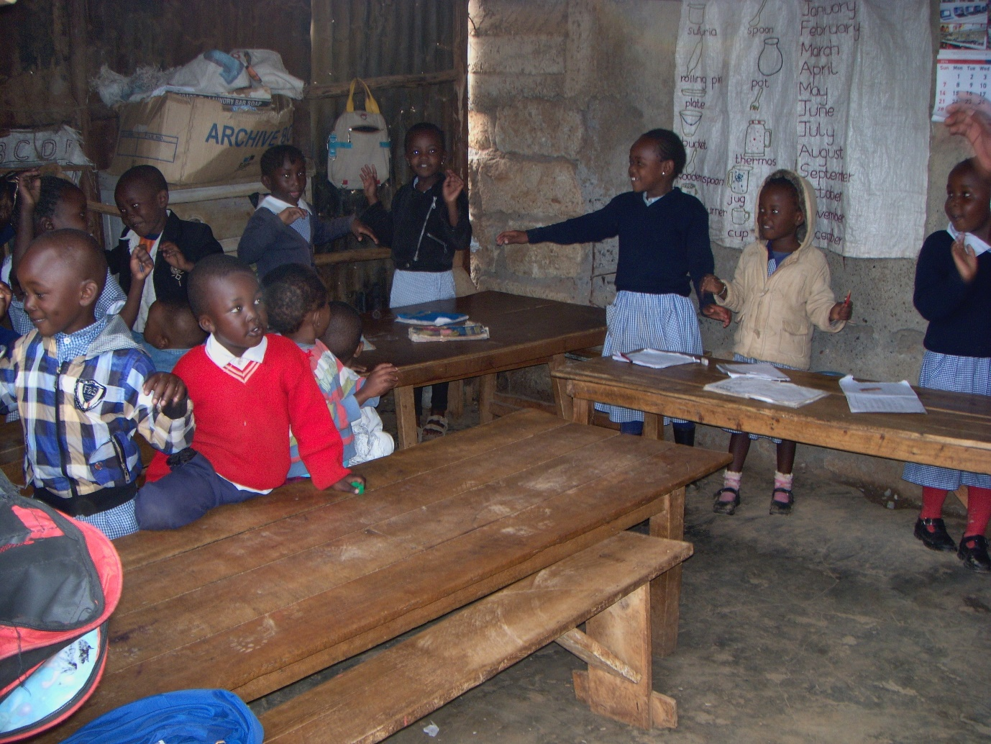
46 Wanyee , dagorreti , Nairobi 00200 , None , Kenya
w:
|ph: +254 00200 +254713517317

Key Contacts

Mr Gilbert okenye
Principal
E: hopemissioncentre12@gmail.com
P: +254713517317 00200 +254713517317
Mr Thomas Clifford
Aassistance
E: thomasclifford76@yahoo.com
P: +254713517317 00200 +254713517317

About my School

Primary language used in school:
English

Foreign languages taught in school:
English
School type:
Years Prep-7 , Non-Government
Is mixed or single-sex:
Mixed
Number of students:
1-50

Specialisation:
Music; Information Technology; Sport; Maths and Science

Special needs support:
No, our school does not cater for special needs

Collaboration Options

Project Preference:
Sister School Partnership (school to school partnership)
Partnership Country:

Partnership Outcome:
our children will learn new culture by sharing through letter writing.
Preferred Partnership Activities:
Class to class email; Student visits; Teacher exchange; Teacher visits
Preferred contact method:
Email
Profile Active / Inactive
Active

Terms and Conditions

I have read and agreed to the Terms and Conditions
Schools Connect

