Welcome, Mumtaza Islamic School
- Management>
- International Education >
- Sister School Partnerships

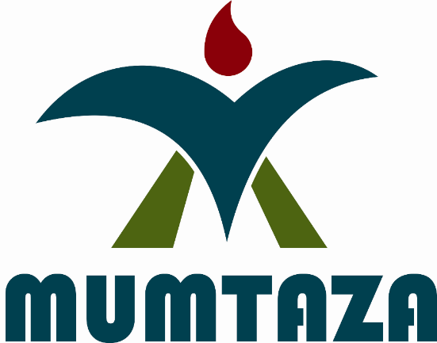
1 Jalan Kayu Manis Raya , Pondok Cabe , Tangerang Selatan 15418 , Banten , Indonesia
w: http://www.mumtaza.sch.id/
|ph: +62 +6221 +622174704241

In this sister school partnership and project collaboration, we are willing to start with teacher exchange in the way the teachers in the respective schools will share ideas about curriculum design and development and teaching learning activities. Here, they are expected to broaden their knowledge and enhance their teaching skills which eventually contributes to teaching and learning. After the teacher exchange takes place, we are planning to go with the student exchange. In this program, the respective schools will represent their student to come and learn in their visited school for about 4 weeks. They are expected to broaden their perspectives and intercultural understanding, enhance their language learning, and contribute to a whole school program of internationalization. In turn, the schools will keep in touch and progressively share ideas by class to class email, curriculum projects, and video communication. All of the aforementioned programs will eventually lead to a solid and sustainable sister school partnership.

Key Contacts

Mr Ibnu Mulyana
Principal
E: hiasibnu@gmail.com
P: +62 +6221 +622174704241
Mr Wewen SJ
Vice Director for Academic and Student Affairs
E: awensj@gmail.com
P: +62 +6221 +622174704241

About my School

Primary language used in school:
English

Foreign languages taught in school:
Arabic; English
School type:
Years Prep-7 , Non-Government
Is mixed or single-sex:
Mixed
Number of students:
501-1000

Specialisation:
Foreign Languages; Information Technology; Sport; Maths and Science

Special needs support:
Yes, some of our students have special needs

Collaboration Options

Project Preference:
Sister School Partnership and Project Collaboration
Partnership Country:
Australia
Partnership Outcome:
In this global era, a partnership between two or more schools plays a significant role in introducing and promoting peace, love, and tolerance to the world. Here, intends to contribute to playing such part. With both Sister School Partnership and Project Collaboration, and the prospective Sister school are expected to keep in touch in terms of student and/or teacher exchange and share ideas especially regarding teaching learning activities and curriculum development to have further develop the respective schools. In addition, both teachers and students in the respective schools are hoped to broaden their perspectives and intercultural understanding, enhance their language learning and contribute to a whole school program of internationalization.
Preferred Partnership Activities:
Class to class email; Curriculum projects; Student visits; Teacher exchange; Teacher visits; Video communication
Type of collaboration:
English; The arts - dance; Health and physical education; The arts - music; Mathematics; Science; Technologies - digital; Languages
Preferred year level:
Year Prep (5 years old); Year 1 (6 years old); Year 2 (7 years old); Year 3 (7 years old); Year 4 (9 years old); Year 5 (10 years old); Year 6 (11 years old)); Year 7 (12 years old); Year 8 (13 years old); Year 9 (14 years old)
Preferred project length:
Up to 4 weeks
Preferred starting date:
22 / 7 / 2,019
Project Outcome:
In this sister school partnership and project collaboration, we are willing to start with teacher exchange in the way the teachers in the respective schools will share ideas about curriculum design and development and teaching learning activities. Here, they are expected to broaden their knowledge and enhance their teaching skills which eventually contributes to teaching and learning. After the teacher exchange takes place, we are planning to go with the student exchange. In this program, the respective schools will represent their student to come and learn in their visited school for about 4 weeks. They are expected to broaden their perspectives and intercultural understanding, enhance their language learning, and contribute to a whole school program of internationalization. In turn, the schools will keep in touch and progressively share ideas by class to class email, curriculum projects, and video communication. All of the aforementioned programs will eventually lead to a solid and sustainable sister school partnership.
Preferred contact method:
Email
Preferred Project Activities:
Class to class email; Curriculum projects; Student visits; Teacher exchange; Teacher visits; Video communication
Profile Active / Inactive
Active

Terms and Conditions

I have read and agreed to the Terms and Conditions

