ISP Student-Initiated Deferral, Suspension and Cancellation Procedure

Purpose
To outline the steps that the Department of Education’s (DE or the department) International Education Division (IED) takes to assess, decide on and record requests by international students to defer, suspend or cancel their enrolment in International Student Program (ISP) courses.
This procedure should be read in conjunction with the ISP Student-Initiated Deferral, Suspension and Cancellation Policy.
This document is intended for students (international students participating in the ISP as the primary holder of a subclass 500 Student – Schools visa) and their parents, education agents, DE (IED) staff, and schools.

Roles and responsibilities

Executive Director, IED
- Establish the framework within which DE (IED) staff make decisions to approve student requests to defer and suspend their enrolment.
- Report deferrals, suspensions or cancellations to the Department of Home Affairs (DHA), as assisted by DE (IED) staff.
- Maintain accurate and up-to-date records consistent with the ISP Record Keeping Procedural Guidelines.

DE (IED) staff
- Provide guidance to students and parents regarding requests for deferrals.
- Assess and decide on student requests to defer or suspend a student’s enrolment.
- Receive notifications of student requests to cancel their enrolment.
- Assist the Executive Director, IED with reporting deferrals, suspensions and cancellations to the DHA.
- Where a student cancels their enrolment and they are living in a homestay, ensure that schools continue to provide appropriate welfare arrangements, and direct schools regarding when to cease provision of welfare arrangements.
- Provide advice and support to school staff to assist them to implement these procedures and the related policy.
- Maintain accurate and up-to-date records consistent with the ISP Record Keeping Procedural Guidelines.

Principal (or delegate)
- Escalate to DE (IED)’s attention circumstances leading to student-initiated suspension or cancellation, based on the circumstances outlined in the ISP Department-Initiated Suspension and Cancellation Policy.

School staff
- Provide guidance to students and parents regarding potential student requests for suspension or cancellation, monitor circumstances that could lead to a student-initiated cancellation, and escalate to the Principal’s (or delegate’s) attention as appropriate.
- Where a student cancels their enrolment and they are living in a homestay, continue to maintain appropriate welfare arrangements for the student until otherwise directed by DE (IED).
- Maintain accurate and up-to-date records consistent with the ISP Record Keeping Procedural Guidelines.

Parent
- Comply with the Written Agreement, by advising DE (IED) before the expected commencement date of the need to defer.
- Notify school of compassionate or compelling circumstances, if applicable.

Student
- Comply with the Written Agreement.
- Notify school of compassionate or compelling circumstances, if applicable.

Student-initiated deferral of enrolment

Parent and student
- Confirm that a Confirmation of Enrolment (CoE) has been issued to the student and their visa has been granted:
- if not, please submit an ISP Change Request Form to the relevant IED case officer (or international@education.vic.gov.au) with the proposed changed date. Do not continue with the procedure below
- if yes, continue with step 2 below.
- After considering the potential visa and course progress implications of a deferral, send an email to international@education.vic.gov.au before the expected course commencement date as follows:
- titled ‘(student name and student ID number), Request for deferral of enrolment, (school name)’
- complete and attach a ISP Change Request Form, ensuring that:
- the parent has signed the form
- it clearly outlined the reason and
- provide documentary evidence of any compassionate or compelling circumstances if a student visa has been granted.
Note that where a student’s visa is not granted and they intend to cancel their enrolment, this is considered in the Student-initiated cancellation of enrolment section of this document. Note that where a student fails to commence within 14 days of the expected commencement date on their CoE, DE (IED) reports this through PRISMS which will result in the CoE being cancelled.

DE (IED) staff
- Assess information provided by students regarding request for compassionate or compelling circumstances.
- If evidence provided is sufficient and school is able to accommodate the deferral, make a decision within 21 days in line with the ISP Student-Initiated Deferral, Suspension and Cancellation Policy. If the decision is to:
- approve the request based on compassionate or compelling circumstances, DE (IED) staff initiate a deferral of the student’s enrolment, including:
- advising the parent or student of the need to seek advice from the Department of Home Affairs on the potential impact on the student’s visa
- report deferral by entering the information in the Provider Registration and International Student Management System (PRISMS) within 14 days of the decision
- consider extending the duration of the student’s study as per the ISP Variation to Student Enrolment Procedure
- reject the request, DE (IED) staff respond in writing to the student or parent notifying them of the outcome, including:
- providing the reasons for refusal
- advising the student of their right to appeal within 20 working days, as outlined in the ISP Complaints and Appeals Policy.
- Maintain records of deferral requests, assessment and decisions as outlined in the ISP Record Keeping Procedural Guidelines.

Parent and student
- Where a deferral request is rejected, decide whether to lodge an internal appeal within 20 working days.

DE (IED) staff
- If an internal appeal is lodged by the student, , adhere to the procedure in the ISP Complaints and Appeals Procedure.

Student-initiated temporary suspension of enrolment

School staff
- Meet with student to discuss any potential suspensions and maintain records of discussions, including:
- reasons for suspension
- written evidence which would be required to support consideration of the suspension
- appropriate timing for any suspension, including academic terms and years, and the timing required to assess an application
- accommodation and welfare arrangement implications, if relevant.
- Attempt to resolve any issues through appropriate student support, intervention and advice.
- If issues unresolved, refer the student to the Application for Temporary Suspension of Enrolment.

Parent and student
- Complete the relevant sections of the Application for Temporary Suspension of Enrolment, including ensuring:
- the student’s parent supports the application, in writing
- the request is acknowledged by the Current Host School
- the student provides written evidence that compassionate or compelling circumstances apply.
- Provide the completed Application for Temporary Suspension of Enrolment and supporting evidence to the Principal (or delegate) within 14 days of the proposed commencement of the temporary suspension.

Principal (or delegate)
- Principal (or delegate) to send an email to the relevant IED School Support Officer (or international.school.support@education.vic.gov.au) with the title ‘Student Request for Temporary Suspension’ within two working days, which includes:
- the completed Application for Temporary Suspension of Enrolment
- the parent has signed the form
- stating the reason and providing written evidence of the issue and any compassionate or compelling circumstances.

DE (IED) staff
- Assess and compile information provided by schools regarding potential suspension, including calling the school to discuss the issue if necessary.
- Request additional evidence from the Principal (or delegate) if required.
- Within 14 days of receiving a completed Application for Temporary Suspension of Enrolment and all supporting evidence, make a decision in line with the ISP Student-Initiated Deferral, Suspension and Cancellation Policy. If the decision is to:
- approve the request based on compassionate or compelling circumstances, DE (IED) staff initiate a suspension of the student’s enrolment, including:
- processing the request and saving the Application for Temporary Suspension of Enrolment form and related evidence in VISIT
- advising the parent and student (and agent if relevant) of the need to seek advice from the Department of Home Affairs on the potential impact on the student’s visa
- report suspension by entering the information in PRISMS within 14 days of decision
- consider extending the duration of the student’s study as per the ISP Variation to Enrolment Procedure.
- reject the request, DE (IED) staff respond in writing to the school staff, parent and student (and agent if relevant), including:
- providing the reasons for refusal
- advising them of the student’s right to appeal within 20 working days. as outlined in the ISP Complaints and Appeals Policy.
- Maintain records of suspension requests, assessment and decisions as outlined in ISP Record Keeping Procedural Guidelines.
- Inform Principal (or delegate), school staff and other relevant DE (IED) staff.

Parent and student
- Where a suspension request is rejected, decide whether to lodge an internal appeal within 20 working days of receiving notice of the decision.

DE (IED) staff
- If an internal appeal is lodged, adhere to the ISP Complaints and Appeals Policy.

Student-initiated cancellation of enrolment

School staff
- Where potential to cancel enrolment is raised by the student or parent:
- discuss any potential decision to cancel enrolment with student and maintain records of discussions, including:
- reasons for cancellation
- appropriate timing for any cancellation, including academic terms and years
- accommodation and welfare arrangement implications, if relevant
- attempt to resolve any issues through appropriate student support, intervention and advice
- if issues unresolved, refer the student to the Withdrawal Form and notify the student to refer to the ISP Refund Policy.
- Identify circumstances that could lead to a student-initiated cancellation, including, visa refusal, deferment, student failure to return to school after an arranged holiday break or suspension, and report to the Principal (or delegate).

Parent and student
- Complete the relevant sections of the Withdrawal Form, outlining which of the following circumstances apply (for transfers to another CRICOS-registered provider, refer to the ISP Transfer Procedure):
- refusal, cancellation or change of visa, and the student provides the relevant letter from the Department of Home Affairs and the completed Refund Request form
- returning home, and the student provides a date of departure
- changing to a new CRICOS-registered provider and the student provides the relevant offer letter or CoE and CAAW (if applicable) letter from the new CRICOS-registered provider.
- Provide the completed Withdrawal Form and supporting evidence to the Principal (or delegate) as soon as possible after deciding to withdraw the student (and within five days of the student’s proposed last day at the school).

Principal (or delegate)
- Principal (or delegate) to send an email to the relevant IED School Support Officer (or international.school.support@education.vic.gov.au) with the title ‘Student Enrolment Cancellation’ within two working days where the Principal (or delegate):
- is notified by school staff of circumstances leading to a student-initiated cancellation
- receives a student request for cancellation of enrolment, including:
- the completed Withdrawal Form, signed by the parent
- supporting evidence
- Maintain records of student-initiated cancellations as outlined in the ISP Record Keeping Procedural Guidelines.

DE (IED) staff
- Assess and compile the information provided regarding the student-initiated cancellation of enrolment, including calling the school to discuss the issue if necessary.
- If evidence provided by Principal (or delegate) is sufficient, respond in writing to acknowledge the cancellation.
- Report cancellation by entering the information in PRISMS within 14 days of:
- a completed Withdrawal Form being received by the Principal (or delegate), or
- school staff identifying circumstances leading to a student-initiated cancellation.
- Check whether the student is eligible for a refund.
- Send an email to parent and student confirming that the student’s enrolment has been cancelled.
- Maintain records of student-initiated cancellation requests and evidence of assessment and outcomes as outlined in the ISP Record Keeping Procedural Guidelines.
- If relevant, continue to check the suitability of care arrangements until the international student has approved welfare arrangements in place, or the student leaves Australia.

School staff
- If relevant, continue to provide welfare arrangements until alternative arrangements are in place, or the student leaves Australia.
- Update enrolment records in CASES21.

Legislation
- Education Services and Overseas Students Act 2000 (Cth)
- National Code of Practice for Providers of Education and Training to Overseas Students 2018 (Cth)
- Migration Act 1958 (Cth)
- Education and Training Reform Act 2006 (Vic)
- Ministerial Order 819 – Fees for Overseas Students in Government Schools (Vic)

Related documents
- ISP Student-Initiated Deferral, Suspension and Cancellation Policy
- ISP Department-Initiated Suspension and Cancellation Policy
- ISP Record Keeping Procedural Guidelines
- ISP Transfer Procedure
- ISP Variation to Enrolment Procedure
- Application for Temporary Suspension of Enrolment
- Withdrawal Form
- ISP Terms, Conditions and Policies
- ISP Complaints and Appeals Policy
- ISP Complaints and Appeals Procedure
- ISP Homestay Policy
- ISP Refund Policy
- ISP Variation to Enrolment Policy
- ISP Transfer Policy
- ISP Guidance on Transfers and Cancellations
- ISP Change Request Form

Definitions
- Compassionate circumstances refers to circumstances that are not in the student’s control or created by the student and adversely impact on student welfare or course progress (for example, illness, bereavement or traumatic events may qualify), as assessed on a case-by-case basis.
- Compelling circumstances are circumstances which in the opinion of DE (IED) are in the student’s best interests, as assessed on a case-by-case basis.
- DE (IED) staff includes the Executive Officers, managers and employees (full time, part time, ongoing, fixed term, casual and contractor) of DE who work directly or indirectly with the ISP. This excludes staff of ISP-accredited schools.
- Homestays are international student accommodation arranged by schools where DE (IED) is responsible for the welfare of the student at all times, including outside school hours.
- International students (students) for the purpose of this policy are defined as students participating in the ISP who are applying for, or hold, a subclass 500 Student – Schools visa
- Parent refers to the parent(s) or legal guardian(s) of an international student
- School staff are employees of schools, for example – International Student Coordinator, Homestay Coordinator, Head of Department, Deputy Principal, and Principal.
- Written Agreement is an agreement with the international student or intending international student and their parent(s) or legal guardian(s), which includes Standard Terms and Conditions; signed by the international student as well as parent(s) or legal guardian(s). The Written Agreement cannot be signed or accepted on behalf of the student or their parent(s) or legal guardian(s) by an Agent.

Policy maintenance officer
- Manager, School Support Unit
- International Education Division
- Department of Education
- Level 28, 80 Collins Street, Melbourne, Victoria 3000
- Email: international.school.support@education.vic.gov.au
- Phone: + 61 3 7022 1000

Authorised
Executive Director, International Education Division

Date of authorisation: 29/11/2019
Review frequency: This procedure will be reviewed at minimum every 12 months or when any changes arise impacting its currency, including legislative or regulatory change.

Appendix 1 – Student-initiated deferral, suspension and cancellation flowchart

Student-initiated request for deferral
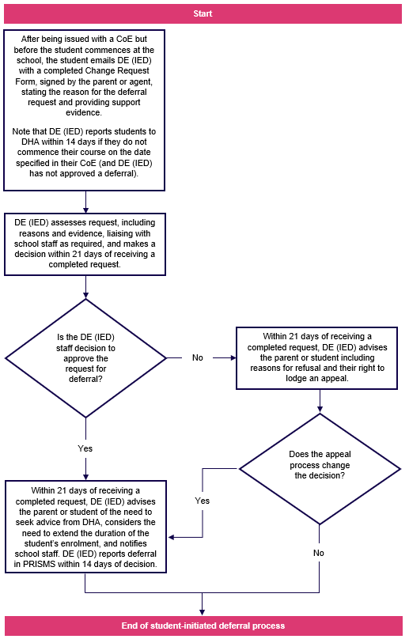

Student-initiated request for temporary suspension
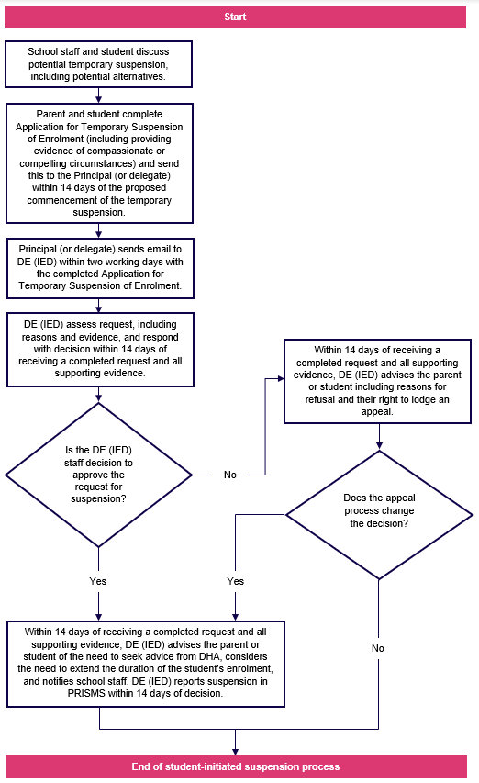

Student-initiated request for cancellation
