International Students – Visa Fee Table
This document is for use by Victorian government schools to determine which international students need to enrol in the department’s International Student Program (ISP) and pay fees, and which international students can be enrolled directly by schools and are exempt from paying fees. Schools can view a 25-minute training video on how to identify and enrol international students which is available online here.
Please note, the terms international student and overseas student are used interchangeably throughout this document and mean the same thing. This International Students – Visa Fee Table is made pursuant to Clause 34 (1) of Ministerial Order 819 - Fees for Overseas Students in Government Schools.

What is an international student?
An international student is an overseas national who comes to Australia on a visa that allows them to study in Australia. They may come to Australia on a student visa with the express purpose of studying at a Victorian government school, such as a secondary student who intends to study their Victorian Certificate of Education (VCE), or as a dependant student who is in Australia with their parents, who are themselves studying in Victoria. Or they may be in Australia as a dependant on their parent’s visa with a purpose other than studying, but their visa allows the dependant to study while in Australia.

Do international students need to pay fees?
Some international students need to pay fees to study in a Victorian government school and some students are exempted from paying fees under this document, depending on the visa they hold.

Which international students pay fees?
To work out which students need to pay fees and enrol in the ISP, schools must:
- Request a copy of the student’s visa grant notice from the student, parent or legal guardian (please see the end of this document for examples of visa grant notices).
- Check the grant notice is in the student’s name (students may have different visa types to their parents)
- Check that the visa date has not expired and note the expiry date. Follow up prior to the expiry date and update their visa status and expiry date in CASES21, if required.
- Refer to the visa fee table in this document to determine whether fees must be paid. This table lists the different visa types and subclass numbers in numerical order and informs you whether the student is exempted from payment of fees or required to pay fees and enrol in the ISP.
You should sight the visa grant notice yourself and take a copy and file in your records.

What about bridging visas?
Bridging visas are issued when someone enters Australia on one type of visa and later applies for another visa. A bridging visa allows the applicant to stay in Australia lawfully once their original visa has expired and while the Australian Government Department of Home Affairs (DHA) makes a decision on their new visa application.
Whether a student is fee liable or fee exempt when they are on a bridging visa is determined by the visa held by the student immediately prior to receiving their bridging visa. If the previous visa held was exempt from paying fees to study in a Victorian government school, the student does not need to pay fees while they are on the bridging visa. However, if the previous visa held was fee liable, then the student continues to be fee liable (even if the new visa they have applied for is fee exempt).

What about humanitarian visa applicants?
An international student is not required to pay fees to attend a government school in Victoria, if they have applied for any one of the following humanitarian visas:
- 051 Bridging (Protection Visa Applicant)
- 302 Emergency (Permanent Visa Applicant) (Repealed 1/07/14)
- 303 Emergency (Temporary Visa Applicant) (Repealed 1/07/14)
- 446 Confirmatory (Temporary) (repealed 1/11/05)
- 447 Secondary Movement Offshore Entry (Temporary) (repealed 9/8/08)
- 448 Kosovar Safe Haven (Temporary) (Repealed 1/07/14)
- 449 Humanitarian Stay (Temporary)
- 450 Resolution of Status - Family Member (Temporary) (repealed 01/07/14)
- 451 Secondary Movement Relocation (Temporary) (repealed 9/8/08)
- 785 Temporary Protection
- 786 Temporary (Humanitarian Concern)
- 787 Witness Protection (Trafficking) (repealed 1/7/09)
- 790 Safe Haven Enterprise
- 866 Protection
The student becomes fee exempt from the day the humanitarian visa application is lodged. The family must provide evidence they have applied for a humanitarian visa to the school. If the student is already enrolled in the ISP as a fee liable student, the family must email a copy of the visa application lodgement to the International Education Division (IED) at: international@education.vic.gov.au. Acceptable evidence of visa application lodgement includes: a visa application lodgement receipt from DHA; an ImmiCard ; or a formal letter issued by the Red Cross (Asylum Seeker's Assistance Scheme) which clearly specifies that the student is included in the visa application and an application has been lodged with DHA.

Students in community detention
Students in community detention who do not hold visas are not required to pay fees. These students are generally supported by AMES Australia in accessing welfare and education services in Victoria. Acceptable evidence includes a letter from DHA (see the example at the end of this document) or AMES Australia (see the example at the end of this document) confirming their current refugee status, or that the student is in community detention, or under residence determination, or have entered Australia not holding a valid visa and has or is intending to apply for asylum. Schools should select 000 in CASES21 for students in community detention once they have sighted and retained the necessary DHA or AMES Australia documentation on file.
Schools receive Student Resource Package (SRP) funding for all humanitarian visa applicants.
The school must continue to monitor the student’s visa status. If the student’s visa application is rejected by DHA, the student may become fee liable. Please contact IED on 7022 1000 or via international@education.vic.gov.au if you have any questions about humanitarian visa applicants.

The international student needs to pay fees, now what?
Direct the student or their family to enrol in the ISP online via the ISP website. The student cannot commence study at your school until they have lodged an application with the IED and paid application and tuition fees in advance. Once IED confirms that the student has enrolled and paid tuition fees, the student can commence. You should record the student’s details in CASES21, including the international student ID number provided by IED, and continue to monitor the student’s visa status and visa expiry date. There are also instances where a previously fee exempt student becomes fee liable once they change their visa. If this occurs, please also follow these steps.

The international student does not need to pay fees, now what?
The student can be enrolled and start immediately at your school. You do not need to enter an international student ID number against the student in CASES21. However, you must continue to monitor the student’s visa status and visa expiry date and, if the student stays beyond their initial visa, you must check their new visa status for fee liability, keep a record of the student’s new visa on file, and if required, update CASES21 with new visa information.

How do schools get paid for international students?
Schools receive SRP funding for international students who are not required to pay fees. These students should be counted in the school census, to ensure schools receives SRP funding.
Schools receive funding from IED for international students who are required to pay fees. Once full payment has been received from the student for each Semester, the funds are disbursed to schools on a quarterly basis. Schools are provided with a school disbursement report to show the disbursement breakdown for each international student. If the international student has not paid their tuition fees, the school is not disbursed any fees, until student payments have been made to IED. This is why schools are asked to help follow up on any outstanding fees with the families of international students.

Does a student need to pay fees if their parent is studying their Masters in Victoria?
Dependant children of a parent studying their Masters in Victoria may be fee exempt or fee liable – it all depends on the visa that the parent and student hold.
If the parent is studying their Masters in Victoria and the parent and student hold a 500 – Higher Education Visa, the student is fee liable.
If the parent is studying their Masters in Victoria and the parent and student hold a 500 – Postgraduate Research Visa, the student is fee exempt.

Does a student need to pay fees if their parent is an Australian Government or Victorian Higher Education Institution scholarship holder?
Dependant children of a parent studying in Victoria are fee exempt when studying in a Victorian government school if their parent is receiving a fully-funded award or scholarship from the Australian Government or from a Victorian Higher Education Institution which meets the full cost of the education component of the award and the parent and student hold a 500 – Higher Education Visa.
You are required to sight documentary evidence that the parent is receiving a full scholarship from the Australian Government or a Victorian Higher Education Institution and to contact IED on 03 7022 1000 or via international@education.vic.gov.au if you have a student you think qualifies for a fee exemption under these circumstances.

What is the school’s responsibility regarding the enrolment of an international student?
It is the school’s responsibility to:
- Check whether a prospective student is an international student.
- Sight a current visa in the student’s name and retain a copy of the visa grant notice on record.
- Use the visa fee table to determine whether the international student is fee liable or fee exempt.
- Record the student’s details in CASES21 and update CASES21 with any subsequent visa changes.
- Instruct fee-liable students to enrol in the ISP before accepting the student’s enrolment and commencement.
- Keep a track of the visa expiry dates and contact the student to confirm and update their visa expiry date and status, prior to the visa expiring.
- Check whether any new visas granted are fee liable or fee exempt.
Schools are required, under the Ministerial Order, to follow these steps to ensure international students are correctly enrolled. Schools may not be paid for the cost of educating a student if they have not been correctly identified as fee liable and instructed by the school to enrol in the ISP.

How can I monitor an international student’s visa status?
Your school can use DHA’s Visa Entitlement Verification Online (VEVO) system, to check what visa an international student currently holds, and any conditions attached to the visa. To look up a visa on VEVO, the student must already be enrolled in the ISP, or you must have permission from the family to look up their visa details.
Your school can register to create a VEVO account here: https://online.immi.gov.au/lusc/register

Where can I get further information?

Enquiries relating to the dependants of international students
Contact the IED by calling 03 7022 1000 or via email at: international@education.vic.gov.au.

Enquiries relating to the dependants of permanent residents
For information relating to schools and enrolments, please contact the relevant regional office – see the Department of Education office locations.
If your query relates to CASES21, please contact the CASES21 helpdesk via the online Services Portal.

Enquiries relating to payments to schools
Schools can access the current Ministerial Order, which includes the Fee Distribution Schedule that applies to all Victorian government schools, including English language Schools / Centres.
Contact IED by calling 03 7022 1000 or via email at: international@education.vic.gov.au.

Visa Sub Class | Overseas Student Category | DET Visa Category | Must pay fees and enrol in the International Student Program | Eligible for Student Resource Package funding through census | Eligible for English Language School / Centre enrolment | International Education Division student ID to be entered on CASES21
000 | Community Detention | Humanitarian | No | Yes | Yes | No
010 | Bridging (Class A) | Bridging | See Note 1 | See Note 1 | Yes | Refer to previous visa held
020 | Bridging (Class B) | Bridging | See Note 1 | See Note 1 | Yes | Refer to previous visa held
030 | Bridging (Class C) | Bridging | See Note 1 | See Note 1 | Yes | Refer to previous visa held
040 | Bridging (Prospective Applicant) D | Bridging | See Note 1 | See Note 1 | Yes | Refer to previous visa held
041 | Bridging (Non-Applicant) D | Bridging | See Note 1 | See Note 1 | Yes | Refer to previous visa held
042 | Bridging (Class A) | Bridging | See Note 1 | See Note 1 | Yes | Refer to previous visa held
050 | Bridging (General) E | Bridging | See Note 1 | See Note 1 | Yes | Refer to previous visa held
051 | Bridging (Protection Visa Applicant) | Humanitarian | No | Yes | Yes | No
060 | Bridging Visa F | Bridging | See Note 1 | See Note 1 | Yes | Refer to previous visa held
070 | Bridging Visa R (Removal Pending) | Bridging | See Note 1 | See Note 1 | Yes | Refer to previous visa held
100 | Partner | Permanent Resident | No | Yes | Yes | No
101 | Child | Permanent Resident | No | Yes | Yes | No
102 | Adoption | Permanent Resident | No | Yes | Yes | No
103 | Parent | Permanent Resident | No | Yes | Yes | No
114 | Aged Dependent Relative | Permanent Resident | No | Yes | Yes | No
115 | Remaining Relative | Permanent Resident | No | Yes | Yes | No
116 | Carer | Permanent Resident | No | Yes | Yes | No
117 | Orphan Relative | Permanent Resident | No | Yes | Yes | No
119 | Regional Sponsored Migration Scheme (repealed 1/7/13) | Permanent Resident | No | Yes | Yes | No
120 | Labour Agreement (repealed 1/7/13) | Permanent Resident | No | Yes | Yes | No
121 | Employer Nomination (repealed 1/7/13) | Permanent Resident | No | Yes | Yes | No
124 | Distinguished Talent - Australian Support | Permanent Resident | No | Yes | Yes | No
126 | Independent (repealed 1/7/12) | Permanent Resident | No | Yes | Yes | No
132 | Business Talent | Permanent Resident | No | Yes | Yes | No
134 | Skill Matching (repealed 1/7/12) | Permanent Resident | No | Yes | Yes | No
135 | State/Territory Nominated Independent (repealed 1/7/12) | Permanent Resident | No | Yes | Yes | No
136 | Skilled – Independent (repealed 1/7/12) | Permanent Resident | No | Yes | Yes | No
137 | Skilled – State/Territory Nominated Independent (repealed 1/7/12) | Permanent Resident | No | Yes | Yes | No
138 | Skilled – Australian-sponsored (repealed 1/7/12) | Permanent Resident | No | Yes | Yes | No
139 | Skilled – Designated Area-sponsored (repealed 1/7/12) | Permanent Resident | No | Yes | Yes | No
143 | Contributory Parent | Permanent Resident | No | Yes | Yes | No
151 | Former resident | Permanent Resident | No | Yes | Yes | No
155 | Resident Return (Five Year) | Permanent Resident | No | Yes | Yes | No
157 | Resident Return (Three Months) | Permanent Resident | No | Yes | Yes | No
159 | Provisional Resident Return | Permanent Resident | No | Yes | Yes | No
160 | Business Owner (Provisional) | Business / Investment | No | Yes | Yes | No
161 | Senior Executive (Provisional) | Business / Investment | No | Yes | Yes | No
162 | Investor (Provisional) | Business / Investment | No | Yes | Yes | No
163 | State/Territory Sponsored Business Owner (Provisional) | Business / Investment | No | Yes | Yes | No
164 | State/Territory Sponsored Senior Executive (Provisional) | Business / Investment | No | Yes | Yes | No
165 | State/Territory Sponsored Investor (Provisional) | Business / Investment | No | Yes | Yes | No
173 | Contributory Parent (Temporary) | Overseas Provisional Parent | Yes | No | Yes | Yes
175 | Skilled - independent (repealed 1/7/13) | Permanent Resident | No | Yes | Yes | No
176 | Skilled - sponsored (repealed 1/7/13) | Permanent Resident | No | Yes | Yes | No
186 | Employer Nomination Scheme | Permanent Resident | No | Yes | Yes | No
187 | Regional Sponsored Migration Scheme | Permanent Resident | No | Yes | Yes | No
188 | Business Innovation and Investment | Business / Investment | No | Yes | Yes | No
189 | Skilled – independent | Permanent Resident | No | Yes | Yes | No
190 | Skilled – nominated | Permanent Resident | No | Yes | Yes | No
191 | Permanent Residence (Skilled Regional) | Permanent Resident | No | Yes | Yes | No
200 | Refugee | Permanent Resident | No | Yes | Yes | No
201 | In-country Special Humanitarian | Permanent Resident | No | Yes | Yes | No
202 | Global Special Humanitarian | Permanent Resident | No | Yes | Yes | No
203 | Emergency Rescue | Permanent Resident | No | Yes | Yes | No
204 | Woman at Risk | Permanent Resident | No | Yes | Yes | No
300 | Prospective Marriage | Overseas Partner | No | Yes | Yes | No
302 | Emergency (Permanent Visa Applicant) (Repealed 1/07/14) | Humanitarian | No | Yes | Yes | No
303 | Emergency (Temporary Visa Applicant) (Repealed 1/07/14) | Humanitarian | No | Yes | Yes | No
309 | Partner (Provisional) | Overseas Partner | No | Yes | Yes | No
310 | Interdependency (Provisional) | Overseas Partner | No | Yes | Yes | No
400 | Temporary Work (Short Stay) | Overseas Visitor | Yes | No | Yes | Yes
401 | Temporary Work (Long Stay) (repealed 19/11/16) | Specialist Entrant | No | Yes | Yes | No
402 | Training and Research (repealed 19/11/16) | Specialist Entrant | No | Yes | Yes | No
403 | Temporary Work (International Relations) | Specialist Entrant | No | Yes | Yes | No
405 | Investor Retirement | Specialist Entrant | No | Yes | Yes | No
406 | Government Agreement (repealed 24/11/12) | Specialist Entrant | No | Yes | Yes | No
407 | Training Visa | Specialist Entrant | No | Yes | Yes | No
408 | Temporary Activity | Specialist Entrant | No | Yes | Yes | No
410 | Retirement (repealed 1/05/05) | Specialist Entrant | No | Yes | Yes | No
411 | Exchange (repealed 24/11/12) | Specialist Entrant | No | Yes | Yes | No
415 | Foreign Government Agency (repealed 24/11/12) | Specialist Entrant | No | Yes | Yes | No
416 | Special Program (repealed 19/11/16) | Specialist Entrant | No | Yes | Yes | No
417 | Working Holiday | Overseas Visitor | Yes | No | Yes | Yes
418 | Educational (repealed 14/9/09) | Specialist Entrant | No | Yes | Yes | No
419 | Visiting Academic (repealed 24/11/12) | Specialist Entrant | No | Yes | Yes | No
420 | Temporary Work Entertainment (repealed 19/11/16) | Specialist Entrant | No | Yes | Yes | No
421 | Sport (repealed 24/11/12) | Specialist Entrant | No | Yes | Yes | No
422 | Medical Practitioner (repealed 24/11/12) | Specialist Entrant | No | Yes | Yes | No
423 | Media and Film Staff (repealed 24/11/12) | Specialist Entrant | No | Yes | Yes | No
424 | Public Lecturer (repealed 1/11/05) | Specialist Entrant | No | Yes | Yes | No
425 | Family Relationship (repealed 1/11/05) | Specialist Entrant | No | Yes | Yes | No
426 | Domestic Worker (Temporary) - Diplomatic or Consular (repealed 24/11/12) | Specialist Entrant | No | Yes | Yes | No
427 | Domestic Worker (Temporary) - Executive (repealed 24/11/12) | Specialist Entrant | No | Yes | Yes | No
428 | Religious Worker (repealed 24/11/12) | Specialist Entrant | No | Yes | Yes | No
430 | Supported Dependant (repealed 1/11/05) | Specialist Entrant | No | Yes | Yes | No
432 | Expatriate (repealed 1/11/05) | Specialist Entrant | No | Yes | Yes | No
442 | Occupational Trainee (repealed 24/11/12) | Specialist Entrant | No | Yes | Yes | No
444 | Special Category (NZ Citizens) | Permanent Resident | No | Yes | Yes | No
445 | Dependent Child | Overseas Partner | No | Yes | Yes | No
446 | Confirmatory (Temporary) (repealed 1/11/05) | Humanitarian | No | Yes | Yes | No
447 | Secondary Movement Offshore Entry (Temporary) (repealed 9/8/08) | Humanitarian | No | Yes | Yes | No
448 | Kosovar Safe Haven (Temporary) (Repealed 1/07/14) | Humanitarian | No | Yes | Yes | No
449 | Humanitarian Stay (Temporary) | Humanitarian | No | Yes | Yes | No
450 | Resolution of Status - Family Member (Temporary) (repealed 01/07/14) | Humanitarian | No | Yes | Yes | No
451 | Secondary Movement Relocation (Temporary) (repealed 9/8/08) | Humanitarian | No | Yes | Yes | No
456 | Business (Short Stay) (repealed 23/3/13) | Overseas Visitor | Yes | No | No | Yes
457 | Temporary Work (Skilled) | Specialist Entrant | No | Yes | Yes | No
461 | NZ Family Relationship Visa | Permanent Resident | No | Yes | Yes | No
462 | Work & Holiday (Temporary) | Overseas Visitor | Yes | No | Yes | Yes
470 | Professional Development (repealed 24/11/12) | Skilled Employees | No | Yes | Yes | No
471 | Trade Skills Training (repealed 10/09/07) | Skilled Employees | No | Yes | Yes | No
475 | Skilled Regional Sponsored (repealed 1/7/13) | Skilled Employees | No | Yes | Yes | No
476 | Skilled - Recognised Graduate | Skilled Employees | No | Yes | Yes | No
482 | Temporary Skill Shortage | Skilled Employees | No | Yes | Yes | No
485 | Temporary Graduate | Skilled Employees | No | Yes | Yes | No
487 | Skilled - Regional Sponsored (repealed 1/7/13) | Skilled Employees | No | Yes | Yes | No
488 | Superyacht Crew (repealed 19/11/16) | Skilled Employees | No | Yes | Yes | No
489 | Skilled - Regional Provisional | Skilled Employees | No | Yes | Yes | No
491 | Skilled Work Regional (Provisional) | Skilled Employees | No | Yes | Yes | No
494 | Skilled Employer Sponsored Regional (Provisional) | Skilled Employees | No | Yes | Yes | No
495 | Skilled Independent Regional (Provisional) (repealed 1/7/12) | Skilled Employees | No | Yes | Yes | No
496 | Skilled - Designated Area Sponsored (Provisional) (repealed 1/7/12) | Skilled Employees | No | Yes | Yes | No
497 | Graduate - Skilled (repealed 1/7/12) | Skilled Employees | No | Yes | Yes | No
500 | Student – AusAID and Defence (Select 5AD on CASES21) | Overseas Student | No | Yes | Yes | No
500 | Student – ELICOS (Select 5EL on CASES21) | Overseas Student | Yes | No | Yes | Yes
500 | Student – Higher Education (Select 5HE on CASES21) | Overseas Student | Yes | No | Yes | Yes
500 | Student – Higher Education – (Aust. Government or Victorian Higher Ed Institution scholarship) (Select 5HS on CASES21) | Overseas Student | No | Yes | Yes | No
500 | Student – Non-Award (Select 5NA on CASES21) | Overseas Student | Yes | No | Yes | Yes
500 | Student – Postgraduate research (Select 5PR on CASES21) | Overseas Student | No | Yes | Yes | No
500 | Student – Schools (all except exchange students – see below)  (Select 5SC on CASES21) | Overseas Student | Yes | No | Yes | Yes
500 | Student – Schools (VRQA Approved Exchange Students ONLY) (Select 5SV on CASES21) | Overseas Student | No | Yes | Yes | No
500 | Student – Vocational Education and Training  (Select 5VE on CASES21) | Overseas Student | Yes | No | Yes | Yes
570 | Independent ELICOS Sector (repealed 30/6/16) | Overseas Student | Yes | No | Yes | Yes
571 | Schools Sector (VRQA Exchange Students ONLY) (repealed 30/6/16) | Overseas Student | No | Yes | Yes | No
571 | Schools Sector (All other overseas school students) (repealed 30/6/16) | Overseas Student | Yes | No | Yes | Yes
572 | Vocational Education and Training (repealed 30/6/16) | Overseas Student | Yes | No | Yes | Yes
573 | Higher Education Sector Masters by Coursework (repealed 30/6/16) | Overseas Student | Yes | No | Yes | Yes
574 | Postgraduate Research Sector (repealed 30/6/16) | Overseas Student | No | Yes | Yes | No
575 | Non-award Foundation / Other Sector (repealed 30/6/16) | Overseas Student | Yes | No | Yes | Yes
576 | Foreign Affairs or Defence Sector (repealed 30/6/16) | Overseas Student | No | Yes | Yes | No
580 | Student Guardian (repealed 30/6/16) (see Note 2) | Overseas Student Guardian | Yes | No | Yes | Yes
590 | Student Guardian (see Note 2) | Overseas Student Guardian | Yes | No | Yes | Yes
600 | Visitor | Overseas Visitor | Yes | No | Yes | Yes
601 | Electronic Travel Authority | Overseas Visitor | Yes | No | Yes | Yes
602 | Medical Treatment | Overseas Visitor | Yes | No | Yes | Yes
651 | e-Visitor Visa | Overseas Visitor | Yes | No | Yes | Yes
675 | Medical Treatment (Short Stay) | Overseas Visitor | Yes | No | Yes | Yes
676 | Tourist (Short Stay) | Overseas Visitor | Yes | No | Yes | Yes
685 | Medical Treatment (Long Stay) (repealed 23/3/13) | Overseas Visitor | Yes | No | Yes | Yes
771 | Transit | Overseas Visitor | Yes | No | No | Yes
773 | Border | Overseas Visitor | Yes | No | No | Yes
785 | Temporary Protection | Humanitarian | No | Yes | Yes | No
786 | Temporary (Humanitarian Concern) | Humanitarian | No | Yes | Yes | No
787 | Witness Protection (Trafficking) (repealed 1/7/09) | Humanitarian | No | Yes | Yes | No
790 | Safe Haven Enterprise | Humanitarian | No | Yes | Yes | No
800 | Territorial Asylum (Residence) | Permanent Resident | No | Yes | Yes | No
801 | Partner | Permanent Resident | No | Yes | Yes | No
802 | Child (Residence) | Permanent Resident | No | Yes | Yes | No
804 | Aged Parent | Permanent Resident | No | Yes | Yes | No
808 | Confirmatory (Residence) | Permanent Resident | No | Yes | Yes | No
814 | Interdependency (Permanent) (repealed 1/7/09) | Permanent Resident | No | Yes | Yes | No
820 | Spouse (Extended Eligibility) | Permanent Resident | No | Yes | Yes | No
826 | Interdependency (Provisional Onshore) (repealed 1/7/09) | Overseas Partner | No | Yes | Yes | No
828 | Limited Extended Eligibility | Permanent Resident | No | Yes | Yes | No
831 | Prospective Marriage Spouse (repealed 1/7/05) | Overseas Partner | No | Yes | Yes | No
832 | Close Ties (repealed 1/11/05) | Permanent Resident | No | Yes | Yes | No
834 | Permanent Resident of Norfolk Island | Permanent Resident | No | Yes | Yes | No
835 | Remaining Relative | Permanent Resident | No | Yes | Yes | No
836 | Carer | Permanent Resident | No | Yes | Yes | No
837 | Orphan relative | Permanent Resident | No | Yes | Yes | No
838 | Aged Dependent Relative | Permanent Resident | No | Yes | Yes | No
845 | Established Business in Australia (repealed 1/7/13) | Permanent Resident | No | Yes | Yes | No
846 | State/Territory Sponsored Regional Established Business (repealed 1/7/13) | Permanent Resident | No | Yes | Yes | No
850 | Resolution of Status (Temporary) (repealed 1/7/14) | Permanent Resident | No | Yes | Yes | No
851 | Resolution of Status (Permanent) | Permanent Resident | No | Yes | Yes | No
852 | Referred Stay (Permanent) | Permanent Resident | No | Yes | Yes | No
855 | Labour Agreement (repealed 1/7/13) | Permanent Resident | No | Yes | Yes | No
856 | Employer Nomination Scheme (repealed 1/7/13) | Permanent Resident | No | Yes | Yes | No
857 | Regional Sponsored Migration Scheme (repealed 1/7/13) | Permanent Resident | No | Yes | Yes | No
858 | Global Talent | Permanent Resident | No | Yes | Yes | No
859 | Designated Parent (repealed 1/7/14) | Permanent Resident | No | Yes | Yes | No
861 | Skilled - Onshore Independent NZ Citizen (repealed 1/7/12) | Permanent Resident | No | Yes | Yes | No
862 | Skilled - Onshore Australian-sponsored NZ Citizen (repealed 1/7/12) | Permanent Resident | No | Yes | Yes | No
863 | Skilled - Onshore Designated Area-sponsored NZ Citizen (repealed 1/7/12) | Permanent Resident | No | Yes | Yes | No
864 | Contributory Aged Parent (Residence) | Permanent Resident | No | Yes | Yes | No
866 | Protection | Permanent Resident | No | Yes | Yes | No
870 | Sponsored Parent (Temporary) visa | Overseas Provisional Parent | Yes | No | Yes | Yes
880 | Skilled – Independent Overseas Student (repealed 1/7/12) | Permanent Resident | No | Yes | Yes | No
881 | Skilled – Australian-sponsored Overseas Student (repealed 1/7/12) | Permanent Resident | No | Yes | Yes | No
882 | Skilled – Designated Area - sponsored Overseas Student (repealed 1/7/12) | Permanent Resident | No | Yes | Yes | No
883 | Skilled Designated Area Sponsored (Residence) (repealed 1/7/12) | Permanent Resident | No | Yes | Yes | No
884 | Contributory Aged Parent (temporary) | Overseas Provisional Parent | Yes | No | Yes | Yes
885 | Skilled - Independent (repealed 1/7/13) | Permanent Resident | No | Yes | Yes | No
886 | Skilled - Sponsored (repealed 1/7/13) | Permanent Resident | No | Yes | Yes | No
887 | Skilled – Regional | Permanent Resident | No | Yes | Yes | No
888 | Business Innovation and Investment | Permanent Resident | No | Yes | Yes | No
890 | Business Owner | Permanent Resident | No | Yes | Yes | No
891 | Investor (Residence) | Permanent Resident | No | Yes | Yes | No
892 | State/Territory sponsored business owner (Residence) | Permanent Resident | No | Yes | Yes | No
893 | State/Territory sponsored investor (Residence) | Permanent Resident | No | Yes | Yes | No
943 | Crew Travel Authority | Overseas Visitor | Yes | No | No | Yes
944 | APEC Travel Authority | Overseas Visitor | Yes | No | No | Yes
945 | Special Purpose | Specialist Entrant | No | Yes | Yes | No
956 | Electronic Travel Authority (Business Entrant - Long) (repealed 23/3/13) | Overseas Visitor | Yes | No | No | Yes
976 | Electronic Travel Authority (Visitor) (repealed 23/3/13) | Overseas Visitor | Yes | No | No | Yes
977 | Electronic Travel Authority (Business Entrant - Short) (repealed 23/3/13) | Overseas Visitor | Yes | No | No | Yes
988 | Maritime Crew | Specialist Entrant | No | Yes | Yes | No
995 | Diplomatic (Temporary) | Specialist Entrant | No | Yes | Yes | No

NOTE 1
The following note applies to Visa Sub Classes 10, 20, 30, 40, 41, 42, 50, 60 and 70, under the following table headers: Must pay fees and enrol in the International Student Program; Eligible for Student Resource Package funding through census; and Eligible for English Language School / Centre enrolment.
Fee liability or exemption is based on the visa held immediately prior to the bridging visa, except where a visa application has been made for a humanitarian visa (see page 2 of this document). Please look up the previous visa in this table to determine fee status. Please note, bridging visas only come into effect when the previous visa expires.
Schools should select 000 in CASES for students in community detention once they have sighted and retained the necessary DHA or AMES documentation on file.
NOTE 2
The following note applies to Visa Sub Classes 590:

School aged dependants of the holders of this visa subclass may be entitled to study for no more than 3 months.

Department of Home Affairs (DHA) – Example of visa grant notice
Please note: the visa example used below is an older visa grant notice, which some students still hold, and is on Department of Immigration and Border Protection letterhead. This was the previous name of DHA.

What to check on the visa
- Check that the visa is in the student’s name.
- Check the visa subclass number and sector type and use the visa fee table to check whether the student is fee liable.
- Check that the visa has not expired (in this example the visa has expired).
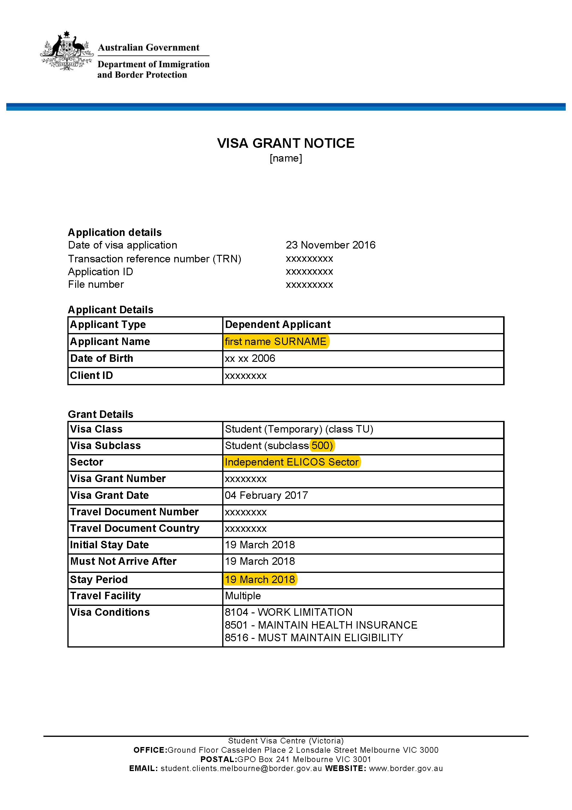
3
2
1

DHA – Example of an unacceptable visa grant notice

What to check on the visa
- This document mentions the student visa subclass but not the sector, so schools cannot determine if the student is fee liable using the visa fee table.
- This document mentions the visa grant date but not the visa expiry date, which must be monitored.
- This document does mention the student’s name.
This document is not acceptable evidence of a 500 visa as it does not contain the visa sector to allow schools to work out fee liability or the visa expiry date. Note: DHA provides visa holders with a more detailed visa grant notice that contains all the necessary information (see example on previous page).
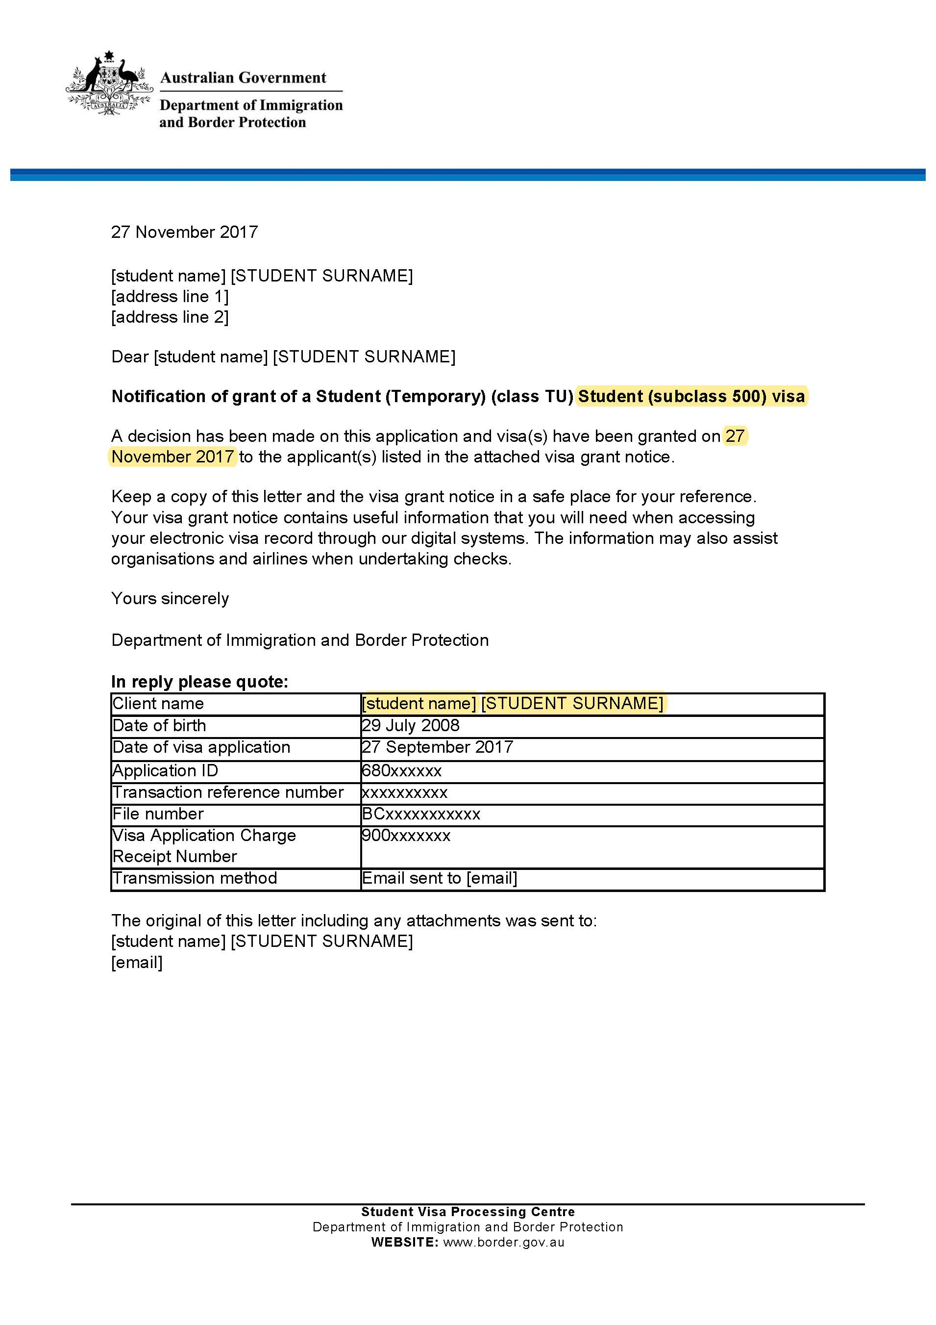
2
1
3

DHA – Example of a Bridging Visa grant notice

What to check on a Bridging Visa
- Read Bridging Visa grant notices carefully. Note in the first highlighted section that DHA have granted a Bridging Visa while the application for a Partner visa is considered. Some schools do not check carefully and presume that the student has already been granted a Partner (subclass 820) visa. This is incorrect and your school may not receive funding if the visa is incorrectly entered.
- Check that the visa is in the student’s name.
- Note that Bridging Visas have grant dates but not expiry dates. This is because DHA do not know how long it will take to process a visa application and the Bridging Visa will remain valid until DHA makes a decision. Note: there have been cases where this takes 18-24 months. You will need to monitor the student’s visa status on a regular basis.
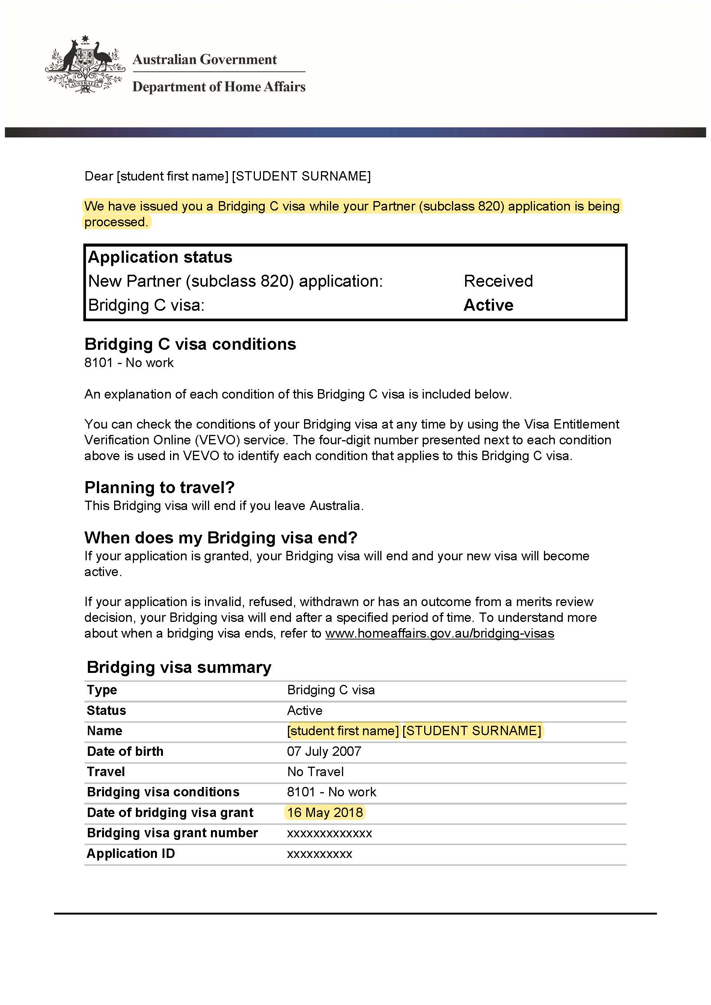
3
2
1

Example of a letter from AMES Australia confirming student’s refugee status

What to check on the letter
- Check the student’s name in the letter matches the student who wants to enrol at your school.
- The letter confirms that the student’s family are asylum seekers who are under a residence determination.
- The letter confirms that the family do not hold visas of any type.
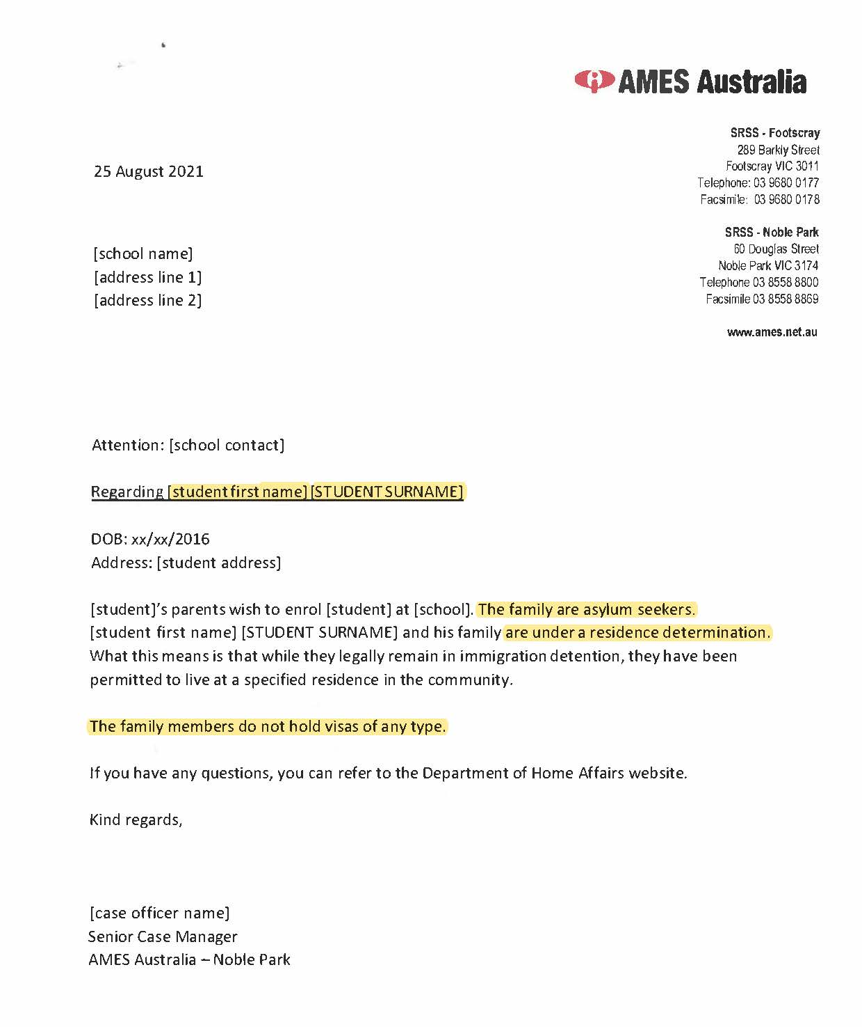
3
2
1

Example of a letter from DHA confirming student’s refugee status

What to check on the letter
- Check the student’s name and DOB in the letter matches the student who wants to enrol at your school.
- The letter confirms that the student does not hold any visa because of their mode of entry into Australia.
- The letter confirms that the student is entitled to engage in education equal to that of an Australian citizen.
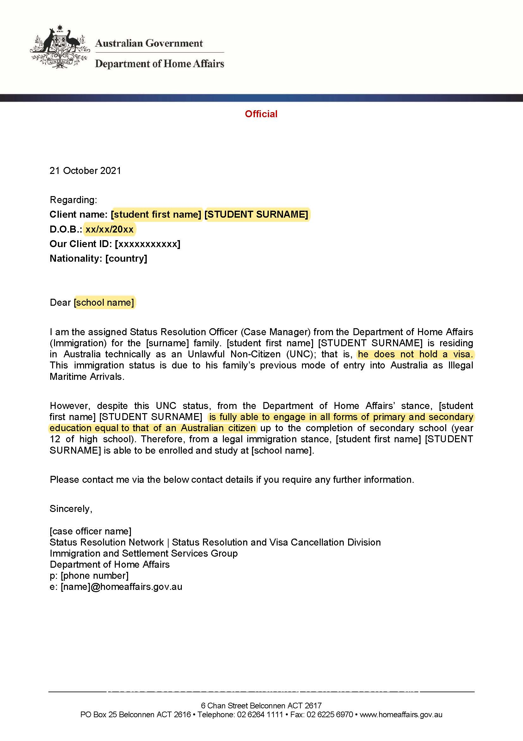
3
2
1

https://youtu.be/GCz-KNj0L6A
For the purpose of this document, the term ‘overseas student’ is used as per Ministerial Order 819 - Fees for Overseas Students in Government Schools. The term international student is used interchangeably. An international student is defined as the primary holder of a student visa (i.e., a student who holds a student visa in their own right) by the Education Services for Overseas Student Act 2000 (Cth).
See the Victorian government schools International Student Program (ISP) website at www.study.vic.gov.au/en/how-to-apply/Pages/default.aspx.
https://www.study.vic.gov.au/en/how-to-apply/Pages/default.aspx
https://www.vic.gov.au/office-locations-department-education
https://services.educationapps.vic.gov.au/dp
https://www.study.vic.gov.au/Shared%20Documents/en/MinisterialOrder819.pdf

