Welcome, Collège Emilien Adam de Villiers
- Management>
- International Education >
- Sister School Partnerships

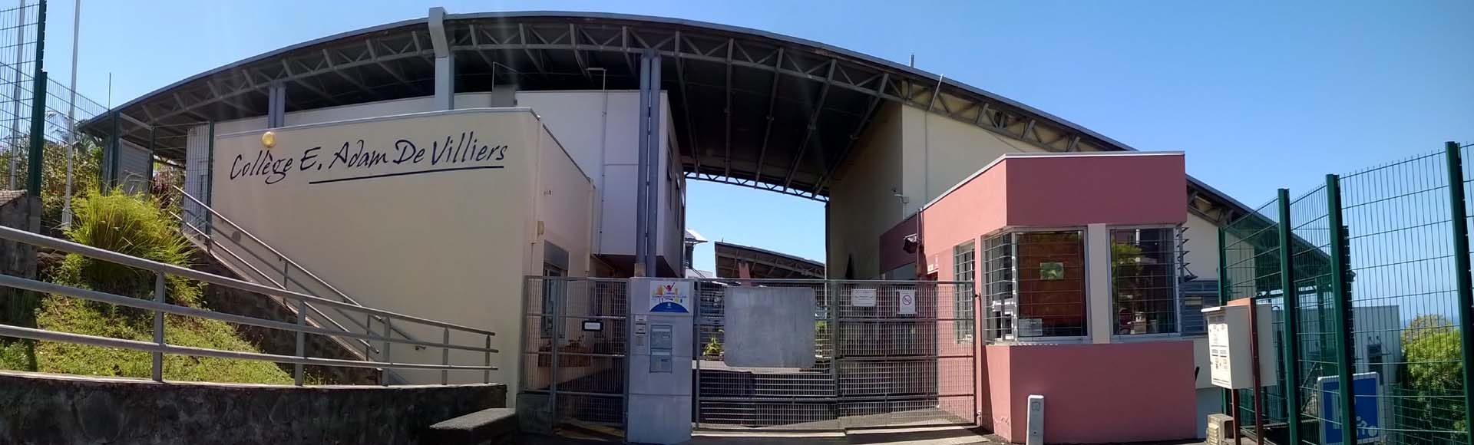
8A Chemin Départemental 29 , La Ravine des Cafres , Saint Pierre 97410 , Île-de-France , France
w: school website
|ph: 262 262 310928

We would like to work on cultural, material and natural heritage and on settlements across the Indian Ocean.

Key Contacts

Mr Denis Simonin
Principal
E: denis.simonin@ac-reunion.fr
P: 00262 262 310928
Mr Adele Lecrosnier
English teacher
E: adele.lecrosnier1@ac-reunion.fr
P: 00262 692 281298

About my School

Primary language used in school:
French (France)

Foreign languages taught in school:
French; German
School type:
Secondary (Years 7-12) , Government
Is mixed or single-sex:
Mixed
Number of students:
251-500

Specialisation:
Foreign Languages; Music; Dance and Drama; Information Technology; Arts; Sport; Maths and Science; Outdoor Education

Special needs support:
Yes, some of our students have special needs

Collaboration Options

Project Preference:
Sister School Partnership and Project Collaboration
Partnership Country:
Australia
Partnership Outcome:
We would like to share some activities with students from Australia and organise a travel exchange.
Preferred Partnership Activities:
Class to class email; School blog; Social media; Student visits
Type of collaboration:
English; The arts - dance; The arts - drama; Health and physical education; The arts - media arts; The arts - music; The humanities - civics and citizenship; The humanities - geography; The humanities - history; Technologies - digital; Languages
Preferred year level:
Year 7 (12 years old); Year 8 (13 years old); Year 9 (14 years old)
Preferred project length:
Up to half a year
Preferred starting date:
1 / 2 / 2,018
Project Outcome:
We would like to work on cultural, material and natural heritage and on settlements across the Indian Ocean.
Preferred contact method:
Email; Video-conferencing
Preferred Project Activities:
Class to class email; School blog; Student visits
Profile Active / Inactive
Active

Terms and Conditions

I have read and agreed to the Terms and Conditions
Schools Connect

