elcome, Moreland Primary School
- Management>
- International Education >
- Sister School Partnerships

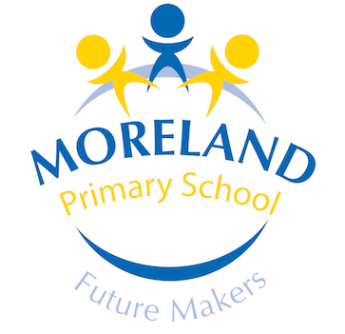
157-163 Moreland Rd , Coburg , Melbourne 3058 , Victoria , Australia
w: Moreland Primary School
|ph: +61 3 93862510

Key Contacts

Mr John Williams
Principal
E: williams.john.g@edumail.vic.gov.au
P: +61 3 93862510
Mr Carley Ternes
Japanese Teacher
E: ternes.carley.c@edumail.vic.gov.au
P: +61 3 93862510

About my School

Primary language used in school:
English

Foreign languages taught in school:
Japanese
School type:
Primary (Years Prep-6) , Government
Is mixed or single-sex:
Mixed
Number of students:
251-500

Specialisation:
Foreign Languages; Music; Information Technology; Arts; Sport; Maths and Science

Special needs support:
Yes, some of our students have special needs

Collaboration Options

Project Preference:
Sister School Partnership (school to school partnership)
Partnership Country:
Japan
Partnership Outcome:
Our school wishes to participate in regular shared language and cultural activities with our sister school via email, video calls and sending things through the mail. In 2019, we are planning an excursion to Japan and would like to spend some time at our sister school. In the future, we would very much like to reciprocate this by welcoming our sister school students to our school. Our school runs two hours of Japanese language classes per week for our students so we are committed to learning Japanese language and the sister school relationship would give a real context for this. We have had a sister school relationship with Japan before so understand what is required to maintain a successful relationship.
Preferred Partnership Activities:
Class to class email; Student visits; Video communication
Preferred contact method:
Email; Phone; Video-conferencing; No preference
Profile Active / Inactive
Active

Terms and Conditions

I have read and agreed to the Terms and Conditions
Schools Connect

