Welcome, Chengdu Shishi Tianfu High School
- Management>
- International Education >
- Sister School Partnerships

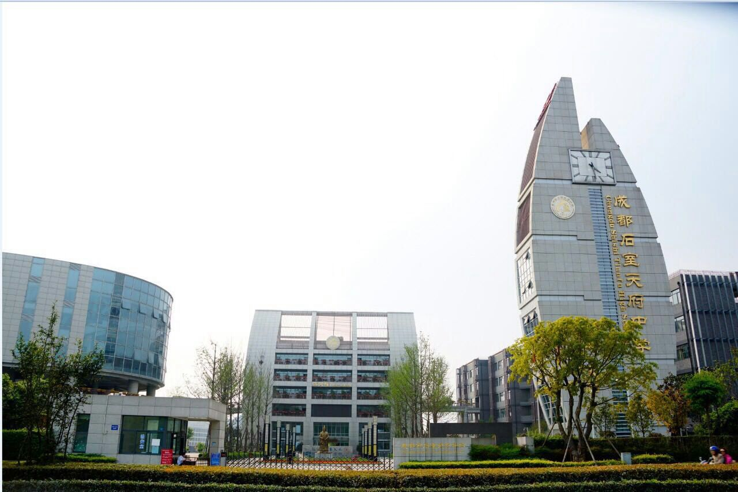
590 North Section Jiannan Avenue , High-tech District , Chengdu 610041 , Sichuan , China
w: http://www.shishitf.net
|ph: 0086 28 69762169

Key Contacts

Mr TANG YU
Principal
E: 314985165@qq.com
P: 0086 28 69762169
Mr LIANG ZILI
Foreign Coordinator
E: cdcfeec@hotmail.com
P: 0086 28 69762169

About my School

Primary language used in school:
Chinese (People's Republic of China)

Foreign languages taught in school:
English
School type:
Secondary (Years 7-12) , Government
Is mixed or single-sex:
Mixed
Number of students:
Above 2000

Specialisation:
Foreign Languages; Music; Arts; Sport

Special needs support:
No, our school does not cater for special needs

Collaboration Options

Project Preference:
Sister School Partnership (school to school partnership)
Partnership Country:
Australia
Partnership Outcome:
1，Mutual respect and friendly exchanges
2，Middle school or high school
3，long-term cooperation
4，Have the same goal
Preferred Partnership Activities:
Class to class email; Curriculum projects; School blog; Social media; Student visits; Teacher exchange; Video communication
Preferred contact method:
Email; Phone; Video-conferencing
Profile Active / Inactive
Active

Terms and Conditions

I have read and agreed to the Terms and Conditions
Schools Connect

