Welcome, Forest Hill College
- Management>
- International Education >
- Sister School Partnerships

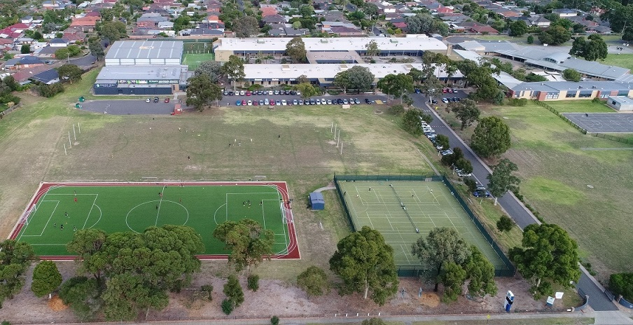
178-180 Mahoneys Road , Burwood East , Melbourne 3145 , Victoria , Australia
w: Forest Hill College website
|ph: 61 3 9814 9444

Key Contacts

Mr David Rogers
Principal
E: rogers.david.l@edumail.vic.gov.au
P: 61 3 9814 9444
Mr Christopher Grant
Assistant Principal
E: grant.chris.c@edumail.vic.gov.au
P: 61 3 9814 9444

About my School

Primary language used in school:
English

Foreign languages taught in school:
Chinese, Mandarin
School type:
Secondary (Years 7-12) , Government
Is mixed or single-sex:
Mixed
Number of students:
501-1000

Specialisation:
Dance and Drama; Sport; Other

Special needs support:
Yes, some of our students have special needs

Collaboration Options

Project Preference:
Sister School Partnership (school to school partnership)
Partnership Country:
Japan
Partnership Outcome:
Forest Hill College has a strong culture of International Education and we are looking to expand our connections across Asia and world. Our school has an Academy program for students in Sports (Soccer, Basketball, Golf, Tennis, Netball and Women's Australian Rules Football) and Performing Arts. Alongside this we have a strong emphasis on STEAM (Science, Technology, Engineering, the Arts, Mathematics) with a new STEAM Centre opening recently in which we study design, coding and robotics.
We are looking to develop a partnership and collaboration with a school in Japan to visit and host in the future, in order to increase the intercultural understanding of our students and staff. We would also welcome the opportunity to use technology to develop connections between our students to work on projects related to STEAM, coding, robotics and/or sustainability.
Preferred Partnership Activities:
Class to class email; Curriculum projects; School blog; Social media; Student visits; Teacher visits; Video communication
Preferred contact method:
Email; Phone; Video-conferencing
Profile Active / Inactive
Active

Terms and Conditions

I have read and agreed to the Terms and Conditions

