Welcome, Silvervide Complex School
- Management>
- International Education >
- Sister School Partnerships

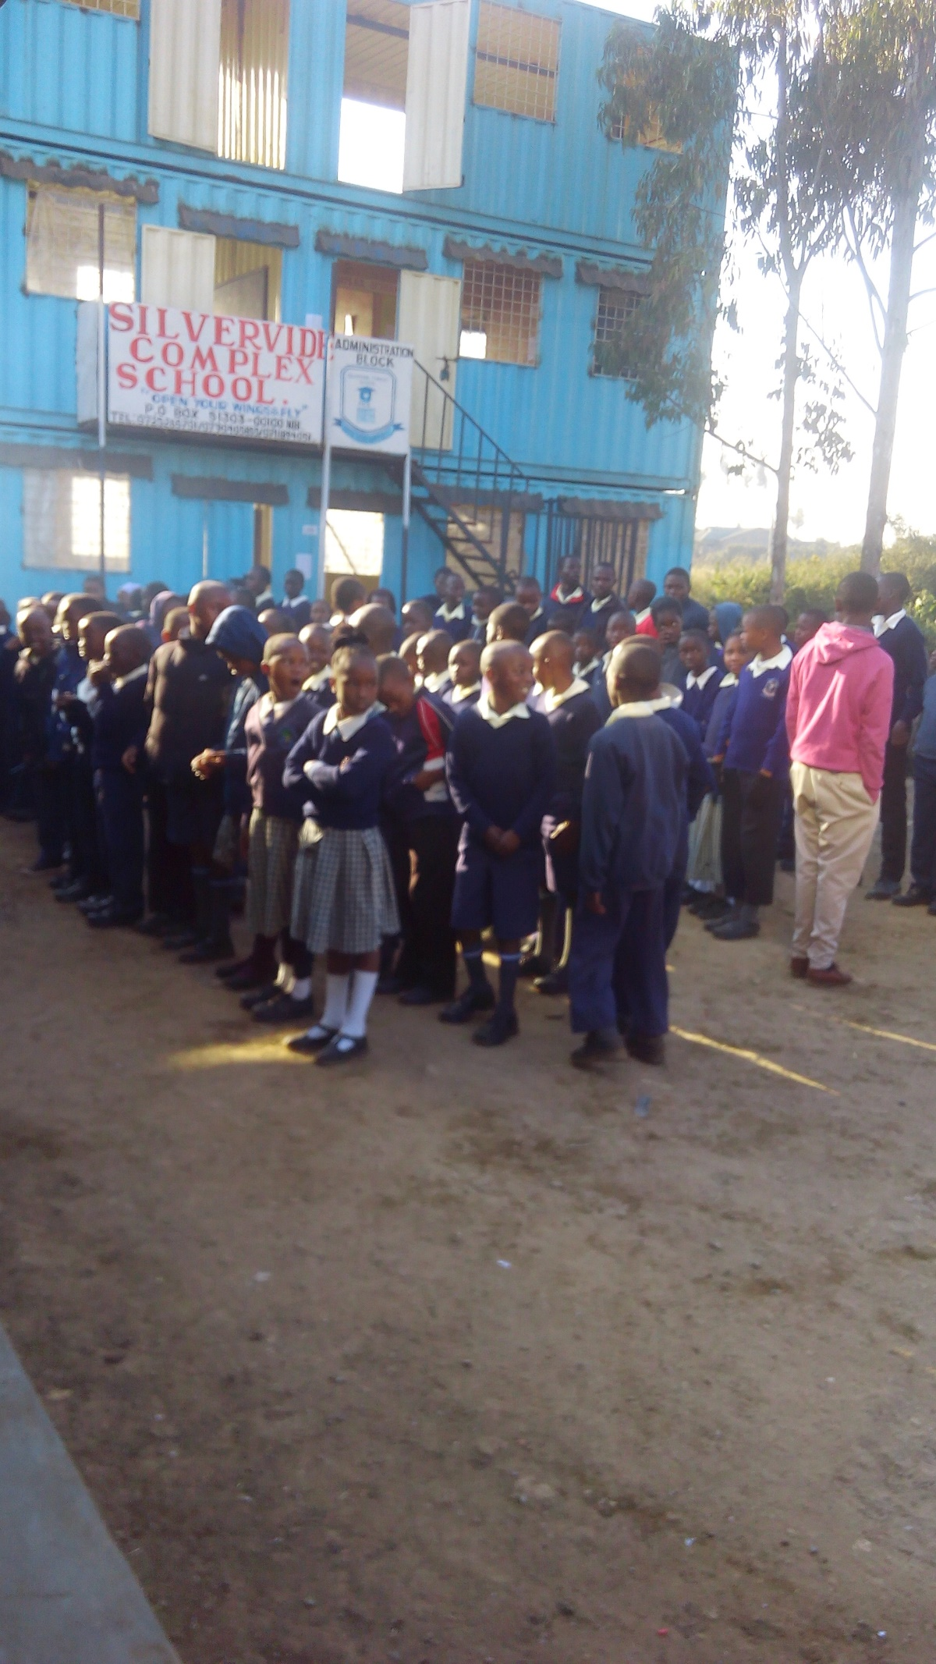
n/a Ngina , n/a , Nairobi 00100 , None , Kenya
w: It shows the school facilities and structure
|ph: +244 +244 0725265701

At the end of the project we hope we'll get to know a lot from you ranging from drama skills ,learning French and much more.we'll also be ready to give back any .

Key Contacts

Mr Benard Ogola
Principal
E: silvervide.complex@gmail.com
P: +254 +254 +254725265701
Mr Dennis Ogola
Assistant administrator
E: dennisoti234@gmail.com
P: +254 +254 0735536863

About my School

Primary language used in school:
English

Foreign languages taught in school:
none
School type:
Primary (Years Prep-6) , Non-Government
Is mixed or single-sex:
Mixed
Number of students:
51-100

Specialisation:
Dance and Drama; Sport; Maths and Science; Outdoor Education

Special needs support:
Yes, some of our students have special needs

Collaboration Options

Project Preference:
Sister School Partnership and Project Collaboration
Partnership Country:
France
Partnership Outcome:
We hope it will yield a good relationship between us which will also link up our students in future and even teachers.I am sure it will be a long life partnership.
Preferred Partnership Activities:
Class to class email; Curriculum projects; School blog; Student visits; Teacher exchange; Teacher visits; Video communication
Type of collaboration:
The arts - drama; Mathematics; Science; Languages
Preferred year level:
Year 5 (10 years old); Year 6 (11 years old)); Year 7 (12 years old); Year 8 (13 years old); Year 9 (14 years old)
Preferred project length:
Up to a year
Preferred starting date:
22 / 9 / 2,016
Project Outcome:
At the end of the project we hope we'll get to know a lot from you ranging from drama skills ,learning French and much more.we'll also be ready to give back any .
Preferred contact method:
Email; Phone; Video-conferencing
Preferred Project Activities:
Class to class email; Curriculum projects; School blog; Student visits; Teacher exchange; Teacher visits
Profile Active / Inactive
Active

Terms and Conditions

I have read and agreed to the Terms and Conditions
Schools Connect

