Welcome, Tucker Road Bentleigh Primary School
- Management>
- International Education >
- Sister School Partnerships

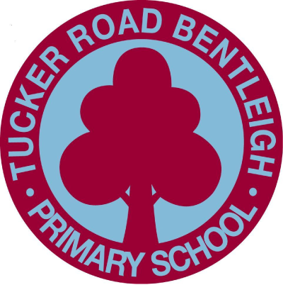
16 Tucker Road , Bentleigh , Melbourne 3204 , Victoria , Australia
w: http://www.tucker-road.vic.edu.au/
|ph: 61 03 95572044

Key Contacts

Mrs Robyn Farnell
Principal
E: farnell.robyn.l@edumail.vic.gov.au
P: 61 03 95572044
Mrs Alana Oro
Italian Teacher
E: oro.alana.m@edumail.vic.gov.au
P: 61 03 95572044

About my School

Primary language used in school:
English

Foreign languages taught in school:
Italian
School type:
Primary (Years Prep-6) , Government
Is mixed or single-sex:
Mixed
Number of students:
501-1000

Specialisation:
Foreign Languages; Music; Information Technology; Arts; Sport; Maths and Science

Special needs support:
Yes, some of our students have special needs

Collaboration Options

Project Preference:
Sister School Partnership (school to school partnership)
Partnership Country:
Italy
Partnership Outcome:
The primary goal in forging a Sister School relationship is communication where the students from each respective school can communicate with each other using diverse means of technology e.g. Skype, or writing letters to each other to ultimately further develop and improve their linguistic competency in both Italian and English. From our point of view, exposing the students to native Italian speakers will aid with the authenticity of learning another language and expose students to elements of the Italian culture which coincides with foreign language learning. Ultimately, a trip to Italy including a school experience, where the students can be fully immersed in the language, culture, history and daily life of an Italian is the scope for pursuing a relationship with a school in Italy.
Preferred Partnership Activities:
Class to class email; Curriculum projects; School blog; Student visits; Teacher exchange; Teacher visits; Video communication
Preferred contact method:
Email; Phone; Video-conferencing
Profile Active / Inactive
Active

Terms and Conditions

I have read and agreed to the Terms and Conditions
Schools Connect

